Software Development Plan (Small Project)

Version 1.0

Revision History

| **Date** | **Version** | **Description** | **Author** |
| --- | --- | --- | --- |
| 02/11/2022 | 1.0 | The initial project plan of Ecommerce website | WinShop |
|  |  |  |  |
|  |  |  |  |
|  |  |  |  |

Software Development Plan

# Introduction

The introduction of the Software Development Plan provides an overview of the entire document. It includes the purpose, scope, definitions, acronyms, abbreviations, references, and overview of this Software Development Plan.

## Purpose

The purpose of the *Software Development Plan* is to gather all information necessary to control the project. It describes the approach to the development of the software and is the top-level plan generated and used by managers to direct the development effort.

The following people use the *Software Development Plan*:

* The **project manager** uses it to plan the project schedule and resource needs, and to track progress against the schedule.
* **Project team members** use it to understand what they need to do, when they need to do it, and what other activities they are dependent upon.

## Scope

This *Software Development Plan* describes the overall plan to be used by the Ecommerce project, including deployment of the product. The plans as outlined in this document are based upon the product requirements as defined in the *Vision Document*.

## Overview

This *Software Development Plan* contains the following information:

Project Overview — provides a description of the project's purpose, scope, and objectives.  It also defines the deliverables that the project is expected to deliver.

Project Organization — describes the organizational structure of the project team.

# Project Overview

## Project Purpose, Scope, and Objectives

## Purpose:

## This project will help people save money and travel time to shop. Then people just need to spend time choosing the right product for their needs.

## Besides shopping, the Winshop also ensures diverse preferential prices and dedicated customer care.

## Scope:

## This project goal is to reach out to everybody, especially young people in Vietnam where with a large buying and selling market. This aims to attract more customers, increase competition while developing better product quality and website performance through customer feedback.

## Objectives:

## It’s needed to have big companies sponsor to advertise the project to everybody. The

## more people we reach, the better it will be for the community.

## Assumptions and Constraints

* Project has a fixed schedule of 12 weeks (6 sprints)
* Budget: 0 USD
* Project has 5 members

## - Project’s development has to be completed by the end of December 2022.

## 2.3. Project Deliverables

Deliverables for each project phase are identified in the Development Case. Deliverables are delivered towards the end of the iteration.

Deliverables could include:

- Test Cases

- Source Code

- Weekly reports

- Test report

- Revised Artifacts submitted in Elaboration

- Software Architecture

- Use-case

- Software Development Plan

- Vision Document

# Project Organization

## Organizational Structure

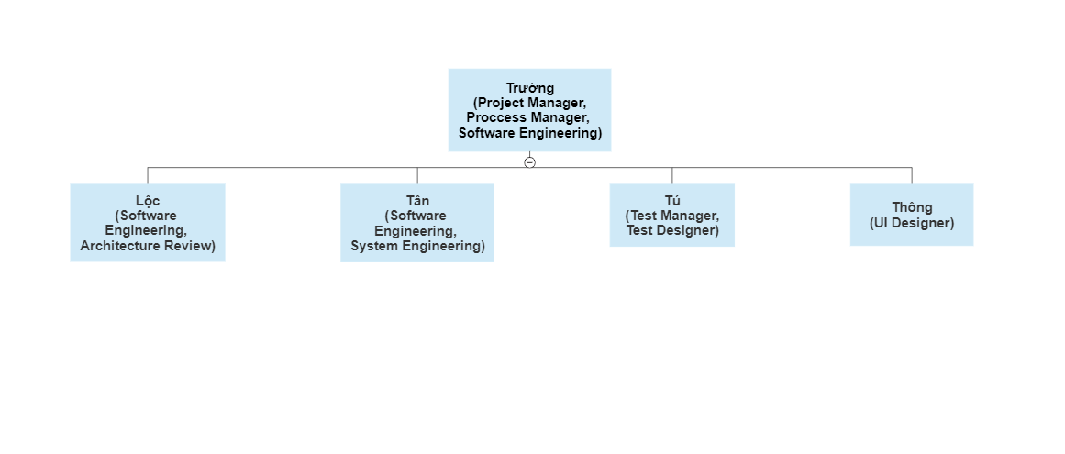

## Roles and Responsibilities

| **Person** | **Role** |
| --- | --- |
| Trường, Project Manager | Responsible for maintaining the project website, assisting the project manager role in planning/scheduling activities and focusing on the project development process. At the same time, it is also possible to provide support for other roles as needed. |
| Lộc, Software Engineering | Focus on developing project functions and Responsible for system technical analysis. |
| Tân, System Engineering | Responsible for performing the backend design of the web system and reviewing the system's architecture. |
| Tú, Test Manager  Thông, Designer | Responsible for software testing, detecting errors, if any, before the product is provided to customers.  Responsible for designing the project's interface and logo. |
|  |  |

# Management Process

## Project Estimates

## Project Plan

* + 1. *Phase and Iteration Plan*

| **Phase** | **Iteration** | **Description** |
| --- | --- | --- |
| Inception | Sprint 1  (20/10/2022 – 02/11/2022) | Defines business model, product requirements, software development plan and business cases |
| Elaboration | Sprint 2  (03/11/2022 – 16/11/2022) | Learning and drawing Use-case Diagram, analysis and design prototype architecture. |
| Sprint 3  (17/11/2022 – 30/11/2022) | Design Database and class Diagram. Implementation and test prototype architecture. |
| Construction | Sprint 4  (01/12/2022 – 14/12/2022) | Implement UI, functions of website, database. |
| Sprint 5  (15/12/2022 – 28/12/2022) | Implement and test use cases, detect and fix errors. Finally, publish Release R1. |

* + 1. *Releases*

Release 1 (R1) must contain as a minimum the basic functionality as listed below:

* Admin’s functions
* Login
* Register for user
* Authentication for users
* Show out products for website
* Comment and evaluate products
* Order products and checkout

*4.2.3 Project Schedule*

| **Phase** | **Iteration** | **Tasks** | **Assignee** | **Start Date** | **End Date** |
| --- | --- | --- | --- | --- | --- |
| Inception | Sprint 1 | Writing SDP | Duy Trường | 20/10/2022 | 27/10/2022 |
| Learning Figma, Design Logo | Gia Thông | 20/10/2022 | 02/11/2022 |
| Learning Reactjs, Frontend | Duy Tân  Xuân Lộc  Quang Tú | 20/10/2022 | 02/11/2022 |
| Learning NodeJs | Duy Trường | 20/10/2022 | 02/11/2022 |
| Writing vision document, writing weekly report | Duy Trường  Gia Thông | 27/10/2022 | 01/11/2022 |
| Elaboration | Sprint 2 | Learn Use-case model and specification | Tất cả | 03/11/2022 | 10/11/2022 |
| Draw Use-case model and Use-case specification | Gia Thông  Quang Tú | 04/11/2022 | 12/11/2022 |
| Use-case specification document | Duy Trường  Xuân Lộc | 03/11/2022 | 12/11/2022 |
| Implement to design UI | Gia Thông | 03/11/2022 | 15/11/2022 |
| Learning to design database | Duy Tân  Duy Trường | 03/11/2022 | 15/11/2022 |
| Update vision document, project plan | Duy Trường | 11/11/2022 | 15/11/2022 |
| Writing weekly report | Gia Thông | 12/11/2022 | 16/11/2022 |
| Learning  NodeJs | Xuân Lộc  Duy Tân  Quang Tú | 03/11/2022 | 16/11/2022 |
| Sprint 3 | Design database | Duy Trường  Duy Tân | 17/11/2022 | 30/11/2022 |
| Learn and design class diagram | Quang Tú  Duy Tân | 17/11/2022 | 25/11/2022 |
| Software Architecture Document (SAD) | Duy Trường  Gia Thông | 25/11/2022 | 30/11/2022 |
| Update use-case specification document | Xuân Lộc | 17/11/2022 | 25/11/2022 |
| Writing weekly report | Gia Thông  Xuân Lộc | 24/11/2022 | 30/11/2022 |
| Construction | Sprint 4 | Code UI | Duy Trường  Xuân Lộc | 01/12/2022 | 13/12/2022 |
| Implement functions of project | Duy Trường  Xuân Lộc  Duy Tân | 01/12/2022 | 13/12/2022 |
| Fix errors of projects | Duy Tân  Quang Tú | 08/12/2022 | 14/12/2022 |
| Update Software Architecture Document | Gia Thông | 01/12/2022 | 08/12/2022 |
| Writing weekly report | Gia Thông | 08/12/2022 | 13/12/2022 |
| Sprint 5 | Test case  Test plan | Quang Tú | 15/12/2022 | 22/12/2022 |
|  | Complete functions of project | Duy Trường  Duy Tân  Xuân Lộc | 15/12/2022 | 23/12/2022 |
| Project Presentation | Tất cả | 24/12/2022 | 27/12/2022 |
| Writing weekly report | Gia Thông | 23/12/2022 | 27/12/2022 |
| Publish Release R1 |  | 23/12/2022 | 27/12/2022 |

## Project Monitoring and Control

### Requirements Management

The requirements for this system are captured in the Vision document. Requested changes to requirements are captured in Change Requests, and are approved as part of the Configuration Management process.

### Reporting and Measurement

### Risk Management

Risks will be identified in Inception Phase using the steps identified in the RUP for Small Projects activity “Identify and Assess Risks” Project risk is evaluated at least once per iteration and documented in this table. The risks of the greatest magnitude are listed first in the table.

| **Risk description** | **Probability** | **Impact** | **Priority** | **Mitigation Strategy or Contingency Plan** |
| --- | --- | --- | --- | --- |
| Bringing low performance | 7/10 | 8/10 | High | During the analyzing and designing phases, optimizing performance is prioritized |
| Work progress is not guaranteed. | 7/10 | 8/10 | High | All members support each other in work  If have a problem, must say it so people can help  Everyone needs to work with the spirit of putting the team's goals first. |
| Asynchrony in the use of tools and technology. | 7/10 | 7/10 | Medium | Before developing, it is necessary to agree on technology tools for development |
| Conflict among group members. | 6/10 | 7/10 | Medium | It is necessary to find out carefully, to prevent conflicts from occurring, if they have occurred, they need to be resolved quickly and thoroughly. |

### Configuration Management

- Slack is a communication tool between members.

- Trello and a tool for tracking working progress.

- Use Google Drive for storing and sharing documents and files.

- Use GitHub for managing source code and related files.